Federalism
Unit 4, Lesson 17 Pp.146-194
Objective (WHAT)-Determine the powers state and federal governments have?
Directions (How)-Read P. 150 of We The People and complete the Venn diagram that is attached
Purpose (Why)-To gain clarity over the concept of federalism
Outcome-The students will understand the term Federalism and how it functions in the United States
Directions;
- Define the following terms; (p. 149)
a. Sovereign
b. Delegated
c. Federal System
d. Federalism
- Read P. 150 from the We The People Text book and complete the Venn diagram below

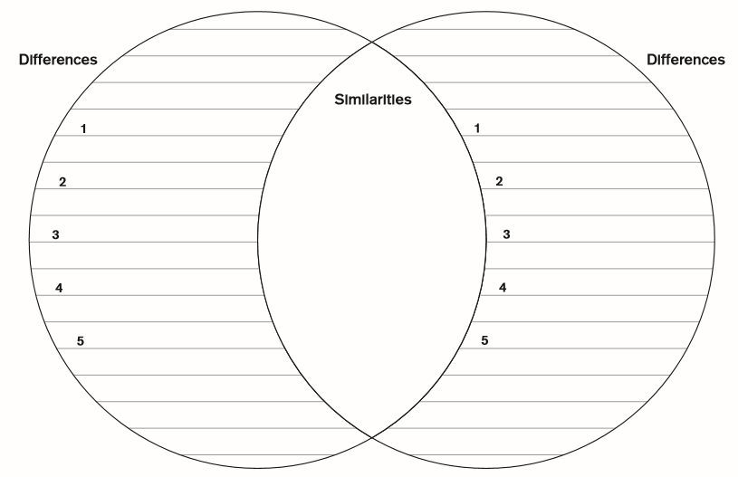
Federal Government
State Governments

Conclusion; We understand that each state and the federal government share some powers and have their own distinct powers. What are several (4) powers that are reserved to the individual that are not delegated to any local, state, or federal government?
a.
b.
c.
d.

