Lesson 18: How did the people approve the new Constitution? Course: 8th Grade SC History
Duration: 2 Class Periods
LEARNING OBJECTIVES:
- Students will be able to define the positions of federalist and anti-federalist.
- Students will be able to analyze how the Constitution of 1787 was ratified.
- Students will be able to explain why South Carolina ratified the Constitution of 1787.
STATE STANDARDS:
- 8-3.1 Explain the tensions between the Upcountry and Lowcountry of South Carolina, including their economic struggles after the Revolutionary War, their disagreement over representation in the General Assembly, the location of the new capital, and the transformation of the state’s economy.
- 8-3.2 Explain the role of South Carolina and its leaders in the Constitutional Convention, including their support of the Three-Fifths Compromise and the Commerce Compromise as well as the division among South Carolinians over the ratification of the Constitution.
LESSON PROGRESSION:
Day 1
Warm Up | 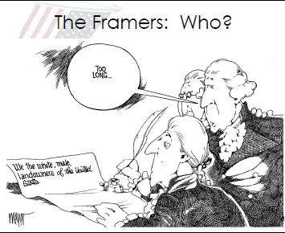  Students will answer the following questions:  - What are the issues that divided the colonies during the Constitutional Convention?  - What is the issue in the cartoon? What is the main point of the image below?
Learning Activities | - Review the key terms, ask students to match the vocabulary word and definition.  - Review the correct definitions with students and have them identify what it is not and write their own definition for each.  - Ratify  - Republic  - Federalist  - Anti-Federalist  - Bill of Rights  - Using popcorn reading strategy have the class read aloud pages 155-159, at that point have students work in partners to answer the following questions:  - Why did the Framers want the people to ratify the Constitution?  - Who were the Federalist and Anti-Federalist?  - What issues related to the new Constitution did the people debate?  - In partners, students will then read through pages 160-161, taking notes in a T-Chart.  - Students will then decide which argument they agree with Federalist or Anti-Federalist. Then complete a constructive response developing their argument and using three pieces of evidence to support their argument.
Closure: | - Submit Constructive Response and Students will also predict how will the conflict be resolved?

Day 2
Warm Up | 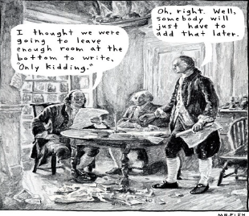  - Ask Students to define the Bill of Rights.  - Have students write two sentences describing what the political cartoon is trying to communicate.
Learning Activities | - Review the role of Federalist and Anti-Federalist at the Constitutional Convention.  - Handback constructive responses and review 3 examples of student work on the smartboard have students evaluate the responses arguments and evidence.  - Next, tell students they are going to decide Should South Carolina Ratify the Constitution of 1787?  - Take a vote, to see what students believe.  - Divide students into groups of 3-4, assign each group the role of Upcounty and Lowcountry. Review the key issues and historical issues such as the regulator movement SC Civil war battles such as Kings Mountain, Economic differences, slavery, New Columbia Capitol, Mistrust of government, political power, etc.  - Students will then use documents and past classnotes to decide how their region would have aligned with in the Federalist vs. Anti-Federalist debate.  - After students decide how each region would have aligned the group must answer the question Should South Carolina Ratify the Constitution of 1787?  - Students must answer the following:  - What are the best arguments for ratifying the constitution?  - What are the best arguments against ratifying the constitution?  - What might happen to South Carolina if does not ratify the Constitution?  - The class will debate and then vote again. Discuss with students the following questions:  - Did anyone change their mind? Why or Why Not  - Do you see any potential problems for the future in the Constitution?  - Do you think the vote to ratify the Constitution was close in states?  - Show students the chart of the Ratifying vote totals and have them write down a summary of the chart in their notes.
Closure | Exit Ticket  - Federalist believe:  - Anti-Federalist believe:  - Most Federalist lived in SC’s ________________________.  - Most Anti-Federalist lived in SC’s ____________________.  - The ratification of the Constitution of 1787 was close. True or False

