We the People Lesson 32 Name: _______________________________

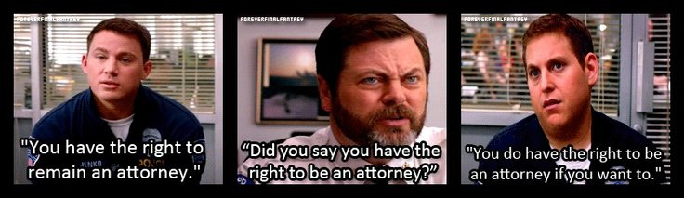
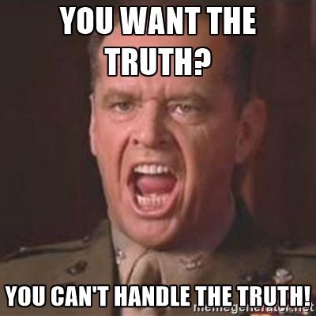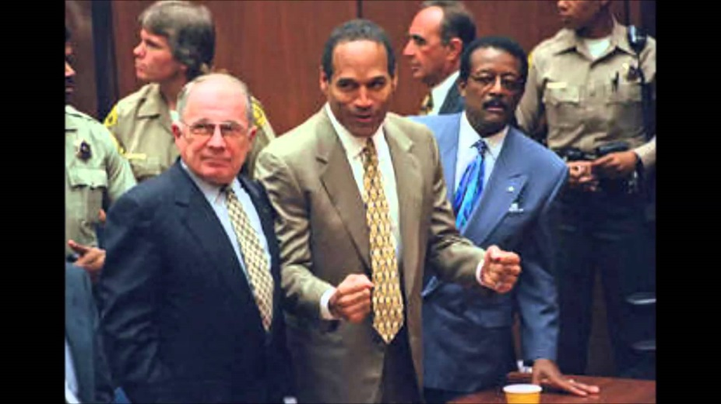

Pretrial rights:
- What is an indictment?

- What is the role of a grand jury?

- Why does the term excessive bail mean in the 8th Amendment?

- Why is the right to counsel important?

During trial rights:
- What are two reasons a speedy trial is in the BoR?

- A public trial is as much a right for the public as it is for the defendant. Why?

- Why is confrontation a right in a courtroom?

- Why does the trial have to be by a jury IN the area the crime was committed?

After trial rights:
- What is double jeopardy, and what is an exception to double jeopardy?

- How can fines be judged by the Equal Protection Clause of the 14th amendment?

- What is an example the book cites of cruel and unusual punishment?

- Why has the court made exceptions to states use of the death penalty?

